SIMATS ENGINEERING

ASSESSMENT TOOL – 1
TITLE: CONCEPT MAPPING
Course Name: Object Oriented Analysis and Design
Course Code: CSA11
Name: Shainey S
Register Number: 192511378

QUESTION 1
Given:
Requirement Analysis → ______ → Coding → Testing → ______ → Maintenance
Concept Map
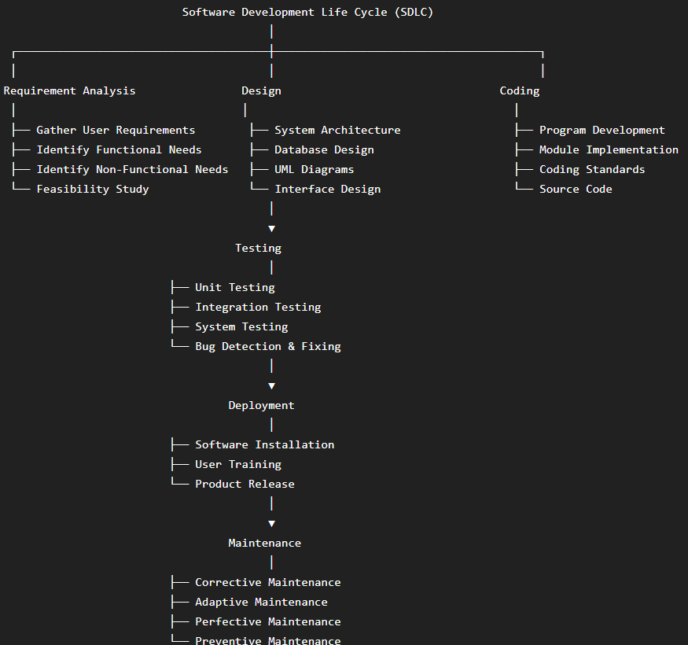

Explanation
The Software Development Life Cycle (SDLC) is a systematic process used to develop high-quality software efficiently. The first phase is Requirement Analysis, where developers collect user requirements, identify system needs, and evaluate project feasibility. The Design phase transforms these requirements into system architecture, database models, UML diagrams, and interface designs. During Coding, developers implement the design into executable programs while following coding standards. The Testing phase verifies that the software works correctly by identifying and fixing errors. Deployment installs the software in the production environment for end users. Finally, Maintenance ensures continuous improvement through bug fixes, updates, and feature enhancements.
Analysis
- Provides a structured approach to software development.
- Reduces development risks and project failures.
- Improves software quality and reliability.
- Enhances communication among development teams.
- Simplifies future maintenance and upgrades.
- Ensures customer requirements are satisfied.

QUESTION 2
Given:
Object-Oriented Principles
→ Abstraction
→ ______
→ Inheritance
→ ______

Concept Map

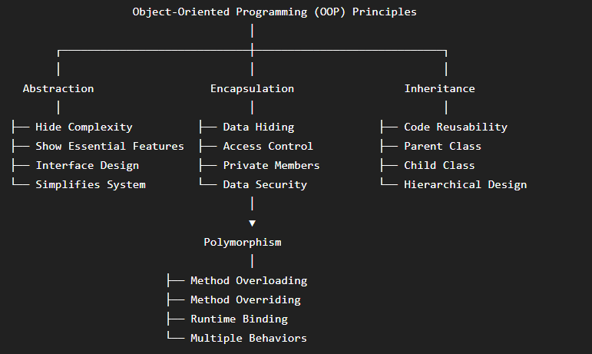

Explanation
Object-Oriented Programming (OOP) is based on four fundamental principles. Abstraction hides unnecessary implementation details while exposing only the essential features of an object. Encapsulation combines data and methods into a single unit (class) and protects data through access modifiers. Inheritance allows a child class to inherit properties and behaviors from a parent class, promoting code reuse and reducing duplication. Polymorphism enables a single interface to represent different behaviors, allowing the same method name to perform different operations depending on the object. Together, these principles improve software quality, flexibility, security, and maintainability.
Analysis
- Promotes reusable and modular code.
- Improves data security through encapsulation.
- Simplifies complex systems using abstraction.
- Reduces code duplication through inheritance.
- Increases flexibility with polymorphism.
- Supports scalable and maintainable software design.

QUESTION 3
Given:
Class → Blueprint
Object → Instance
Method → ______
Attribute → ______
Concept Map
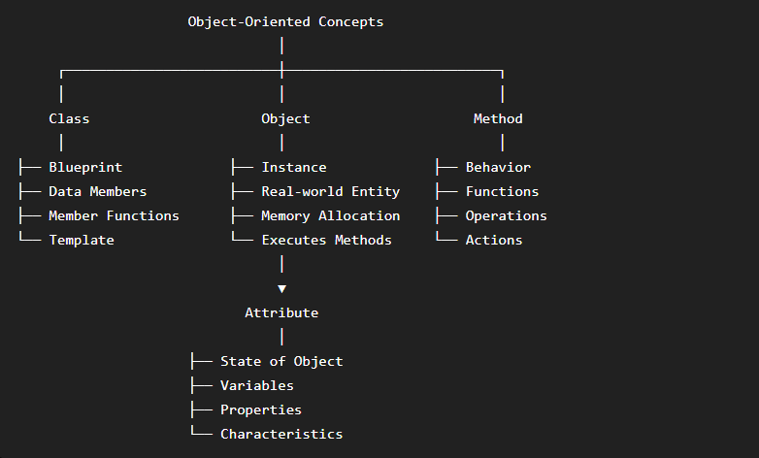

Explanation
A Class is a blueprint that defines the structure and behavior of objects. It contains attributes (data members) and methods (member functions). An Object is an instance of a class that occupies memory and represents a real-world entity. Methods define the actions or behaviors that an object can perform, such as displaying information or calculating values. Attributes describe the properties or state of an object, such as name, age, or salary. Together, classes and objects form the foundation of Object-Oriented Programming and help model real-world systems effectively.

Analysis
- Represents real-world entities efficiently.
- Improves modularity and code organization.
- Makes software easier to understand and maintain.
- Encourages code reuse through class design.
- Supports abstraction and encapsulation.
- Forms the basis of Object-Oriented Analysis and Design.

QUESTION 4
Given:
Software Quality
→ Reliability
→ ______
→ Maintainability

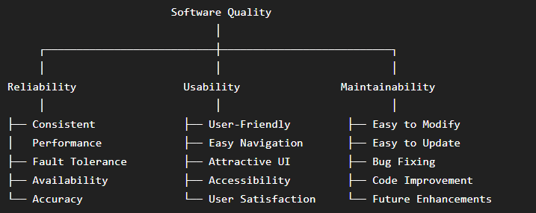

Explanation
Software quality refers to the degree to which software meets user expectations and performs efficiently. Reliability ensures that the software functions correctly under different conditions without failure. Usability focuses on how easily users can learn and interact with the software through a simple and intuitive interface. Maintainability ensures that developers can easily modify, update, debug, and improve the software after deployment. These quality attributes together improve software performance, customer satisfaction, and long-term sustainability.
Analysis
- Improves user experience and customer satisfaction.
- Reduces software failures and system downtime.
- Simplifies maintenance and future upgrades.
- Increases software reliability and performance.
- Supports long-term software evolution.
- Enhances overall product quality.

QUESTION 5
Given:
UML
→ Structural Diagrams → ______
→ Behavioral Diagrams → Activity Diagram
→ Interaction Diagrams → ______
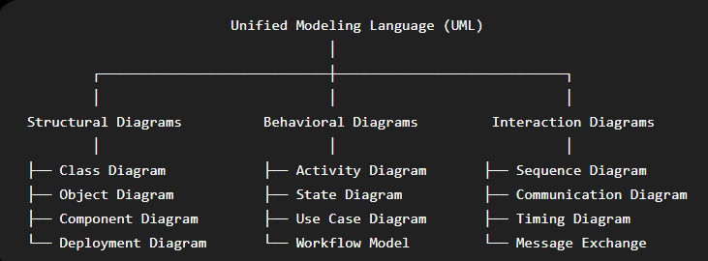

Explanation
Unified Modeling Language (UML) is a standard graphical language used to visualize, design, and document software systems. Structural diagrams describe the static structure of a system, including classes, objects, and components. Behavioral diagrams illustrate how the system behaves over time, including activities, states, and workflows. Interaction diagrams focus on communication between objects through messages and method calls. UML improves communication among developers, analysts, and stakeholders while simplifying software design and documentation.
Analysis
- Provides a standardized modeling language.
- Improves system visualization and documentation.
- Enhances communication among stakeholders.
- Simplifies software analysis and design.
- Helps identify design issues early.
- Supports object-oriented software development.

QUESTION 6
Given:
Requirements ✔ → Design ✔ → Coding ✖ → Testing ✖ → Deployment ✖
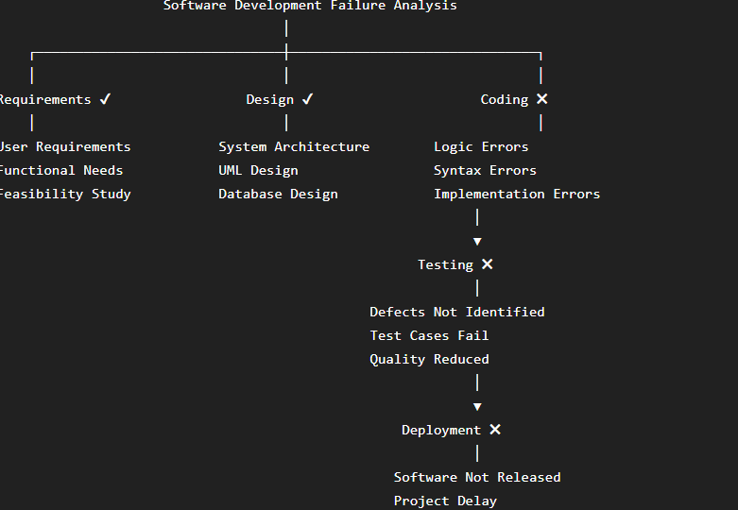

Explanation
In this software development process, the project successfully completes the Requirement Analysis and Design phases. However, failure occurs during the Coding phase due to implementation, syntax, or logical errors. Because the code contains defects, the Testing phase cannot be completed successfully, leading to unsuccessful verification of software functionality. As a result, the software cannot proceed to the Deployment phase. Proper coding practices, code reviews, and testing strategies are essential to avoid such failures.
Analysis
- Coding errors directly affect software quality.
- Failed testing delays project completion.
- Deployment becomes impossible without successful testing.
- Code reviews reduce implementation mistakes.
- Following coding standards improves reliability.
- Early defect detection reduces maintenance costs.

QUESTION 7
Given:
Problem Identification → ______ → Design → Implementation → ______

Concept Map
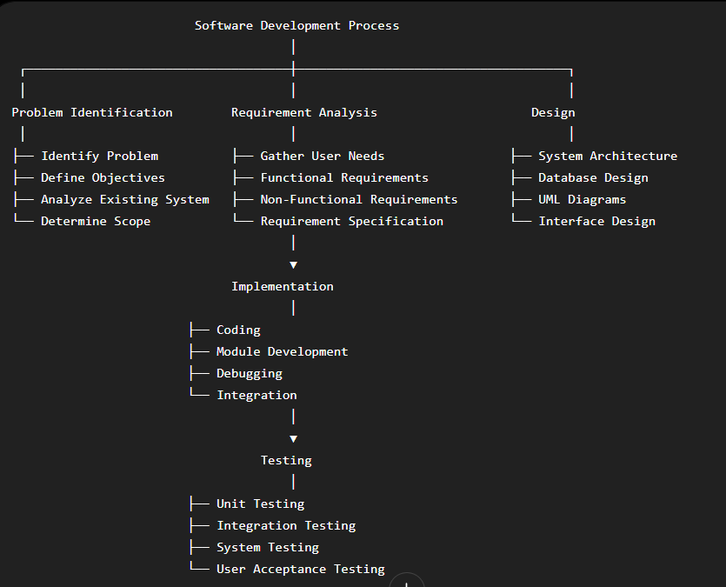

Explanation
The software development process begins with Problem Identification, where developers understand the problem and define project objectives. During Requirement Analysis, user requirements are collected and documented to create a Software Requirement Specification (SRS). The Design phase converts requirements into system architecture, database design, and UML models. Implementation involves coding and integrating software modules. Finally, Testing ensures that the software functions correctly, satisfies user requirements, and is free from defects before deployment.
Analysis
- Clearly defines project objectives.
- Reduces misunderstandings between developers and users.
- Improves software quality through systematic development.
- Detects defects before deployment.
- Ensures software meets customer requirements.
- Supports successful project completion.

QUESTION 8

Given:
Object-Oriented Features
→ Class
→ ______
→ Message Passing
→ ______
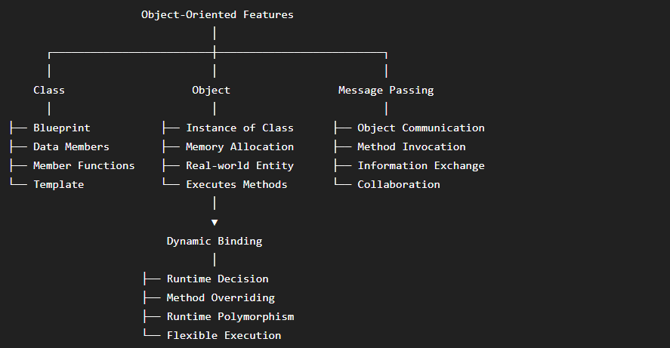

Explanation
Object-Oriented Programming is based on several important features. A Class acts as a blueprint that defines the structure and behavior of objects. An Object is an instance of a class that contains actual data and methods. Message Passing enables objects to communicate by sending and receiving messages through method calls. Dynamic Binding determines which method should be executed at runtime, allowing runtime polymorphism and greater flexibility. These features make software modular, reusable, and easier to maintain.
Analysis
- Encourages modular software design.
- Supports runtime flexibility.
- Promotes code reusability.
- Improves communication among objects.
- Simplifies maintenance and debugging.
- Enables runtime polymorphism.

QUESTION 9
Given:
Software Development Models
→ Waterfall
→ ______
→ Spiral
→ ______

Concept Map
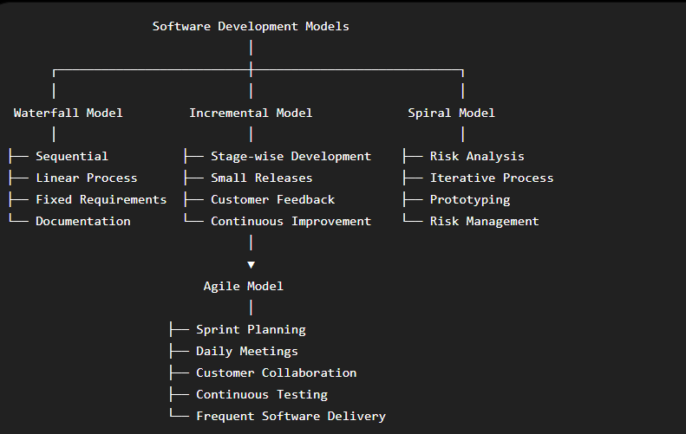

Explanation
Software Development Models provide structured approaches for developing software. The Waterfall Model follows a sequential process where each phase is completed before moving to the next. The Incremental Model develops software in smaller modules, allowing early delivery and continuous feedback. The Spiral Model combines iterative development with risk analysis, making it suitable for large and complex projects. The Agile Model emphasizes customer collaboration, rapid development, continuous testing, and frequent software releases through iterative sprints.
Analysis
- Helps select the appropriate development methodology.
- Improves project planning and management.
- Reduces project risks.
- Supports continuous customer feedback.
- Enables faster software delivery.
- Enhances software quality and adaptability.

QUESTION 10

Given:
Class Diagram
→ Class
→ ______
→ Association
→ ______

Concept Map

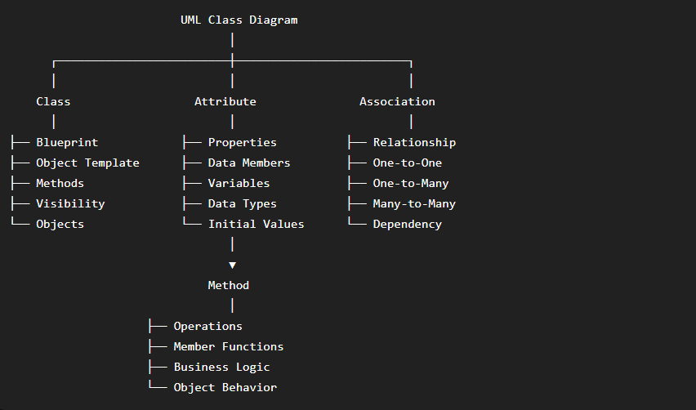

Explanation
A Class Diagram is one of the most important UML structural diagrams used in Object-Oriented Analysis and Design. It represents the static structure of a system by showing classes, their attributes, methods, and relationships. A Class acts as a blueprint for creating objects. Attributes define the properties or characteristics of a class, while Methods specify the operations or behaviors performed by objects. Associations describe how classes interact and communicate with one another. Class diagrams help developers understand system architecture before implementation.
Analysis
- Represents the static structure of a software system.
- Improves software documentation.
- Simplifies communication among developers.
- Supports object-oriented design principles.
- Helps identify relationships between classes.
- Reduces design errors before coding.

QUESTION 11
Given:
Software Engineering Principles
→ Modularity
→ ______
→ Reusability
→ ______

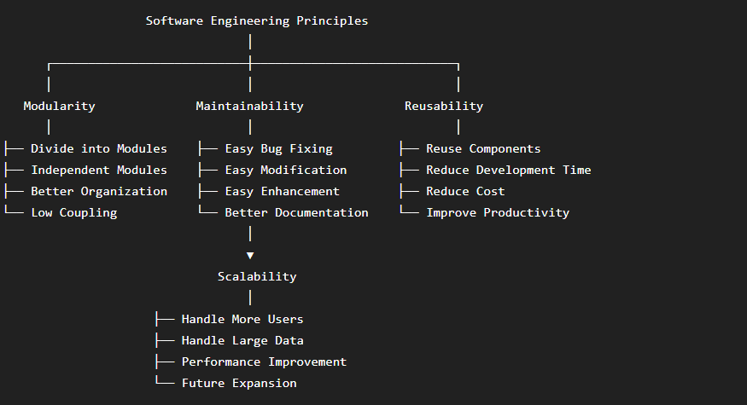

Explanation
Software Engineering Principles provide guidelines for building efficient, maintainable, and high-quality software. Modularity divides a system into independent modules, making development and testing easier. Maintainability ensures that software can be modified, updated, and debugged with minimal effort. Reusability allows developers to reuse existing code and components in different applications, reducing development time and cost. Scalability enables software to handle increasing workloads, users, and data without affecting performance.
Analysis
- Improves software quality and performance.
- Simplifies software maintenance.
- Reduces overall development cost.
- Encourages code reuse.
- Supports future software expansion.
- Increases system reliability.

QUESTION 12
Given:
Requirement Analysis ✔ → System Design ✔ → Coding ✔ → Integration ✖ → Deployment ✖

Concept Map
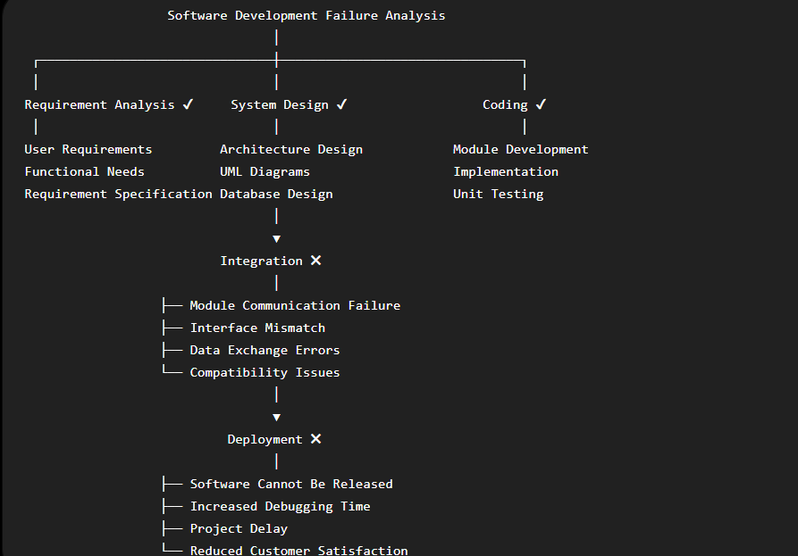
Explanation
In this software development process, the Requirement Analysis, System Design, and Coding phases are completed successfully. However, failure occurs during the Integration phase because individual software modules fail to communicate correctly. Common reasons include interface mismatches, incompatible modules, and incorrect data exchange. Since integration is unsuccessful, the software cannot move to the Deployment phase. Integration testing, interface verification, and compatibility checks are essential to ensure smooth communication between modules before deployment.
Analysis
- Identifies integration-related software failures.
- Prevents deployment of defective software.
- Encourages effective integration testing.
- Improves module compatibility.
- Reduces debugging effort and project delays.
- Enhances software quality and customer satisfaction.

